

***INSTITUTE OF INFORMATION TECHNOLOGY***

***JAHANGIRNAGAR UNIVERSITY***

**Number of Assignment:** 03

**Submission Date :** 29/12/2021

**Course Tittle :** Database Management System Lab

**Course Code :** ICT - 2204

**Submitted To Submitted By**

Manan Binth Taj Noor Md. Shakil Hossain

Lecturer Roll – 2023

IIT – JU 2nd year 2nd Semester

IIT – JU

**ASCII**

Return the ASCII value of the first character in Cust_name.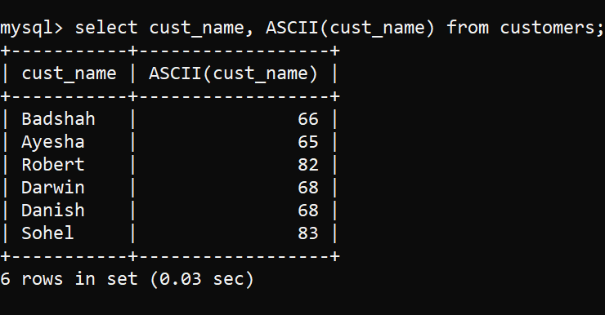

**CHAR_LENGTH**

Return the length of the string (in characters)

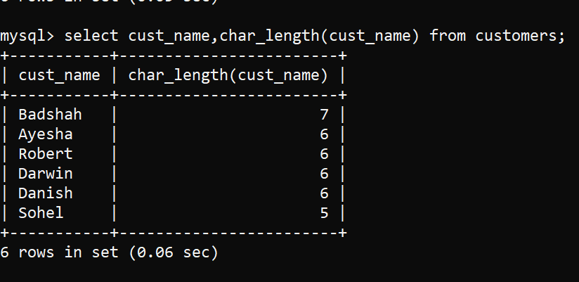

**CHARACTER_LENGTH**

Return the length of the string (in characters)

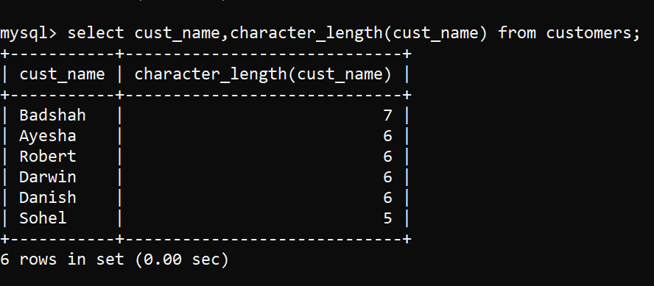

**CONCAT**

The CONCAT( ) function adds two or more expressions together.

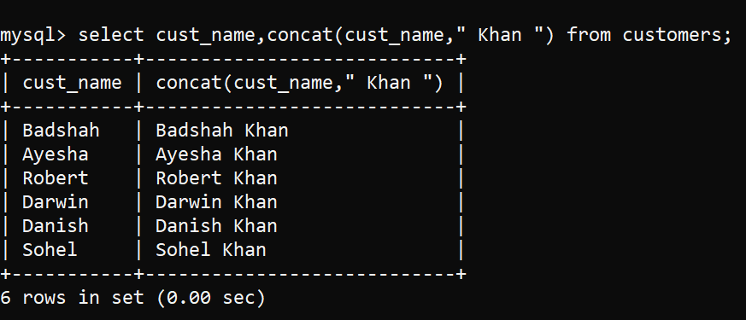

**CONCAT_WS**

The CONCAT_WS() function adds two or more expressions together with a separator.

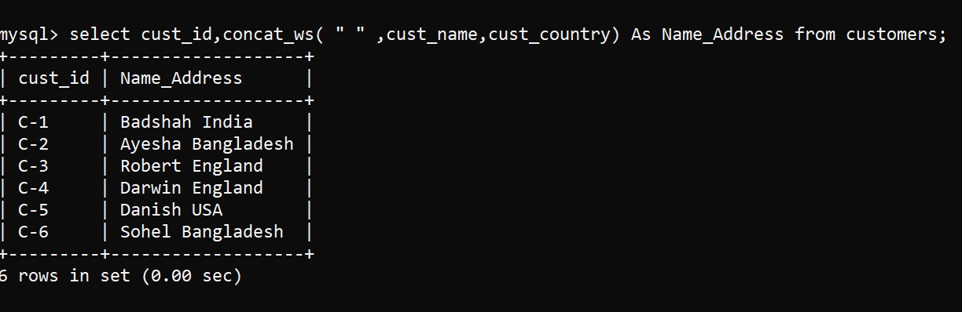

**FIELD**

The FIELD() function returns the index position of a value in a list of values.

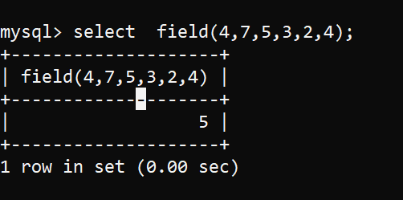

**FIELD_IN_SET**

The FIND_IN_SET() function returns the position of a string within a list of strings.

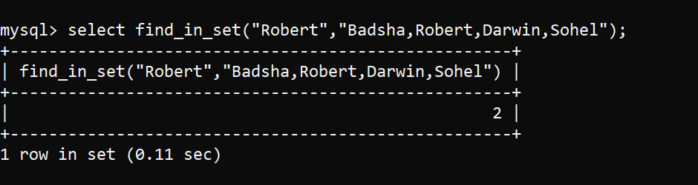

**FORMAT**

The FORMAT() function formats a number to a format like "3.1415321", rounded to a specified number of decimal places, then it returns the result as a string.

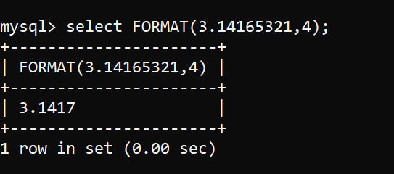

**INSERT**

The INSERT() function inserts a string within a string at the specified position and for a certain number of characters.

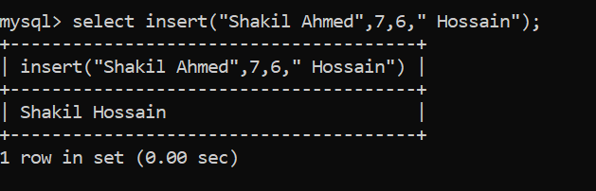

**INSTR**

The INSTR() function returns the position of the first occurrence of a string in another string.

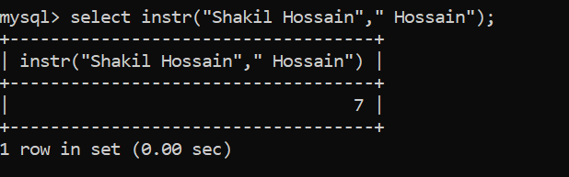

**LCASE**

The LCASE() function converts a string to lower-case.

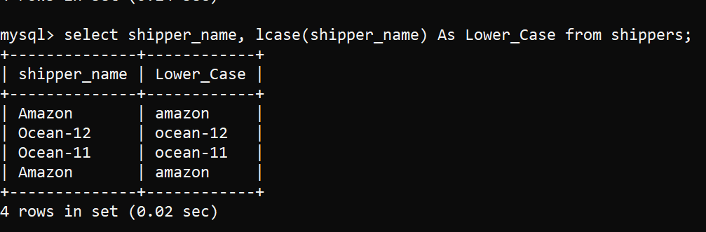

**LEFT**

The LEFT( ) function extract left character from string

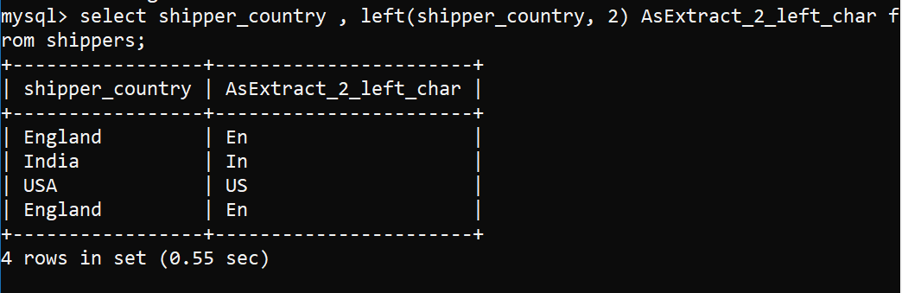

**LENGTH**

The LENGTH( ) function finds the String length.

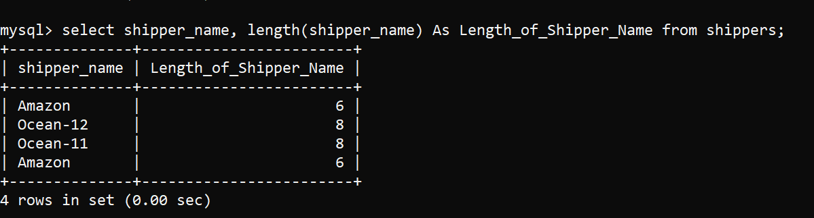

**LOCATE**

The LOCATE() function returns the position of the first occurrence of a substring in a string.

If the substring is not found within the original string, this function returns 0. This function performs a case-insensitive search.

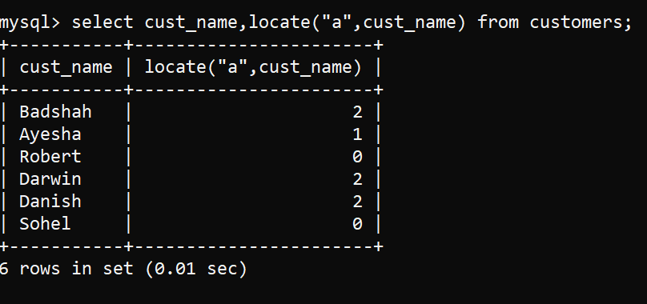

**LOWER**

The LOWER() function converts a string to lower-case.

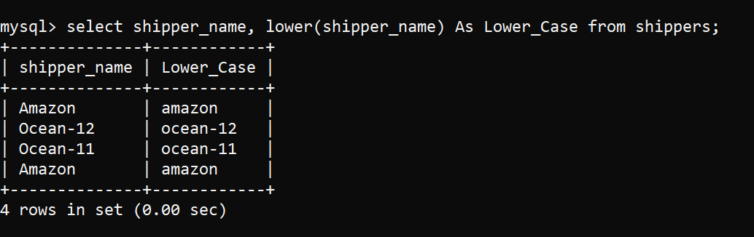

**LPAD**

The LPAD() function left-pads a string with another string, to a certain length

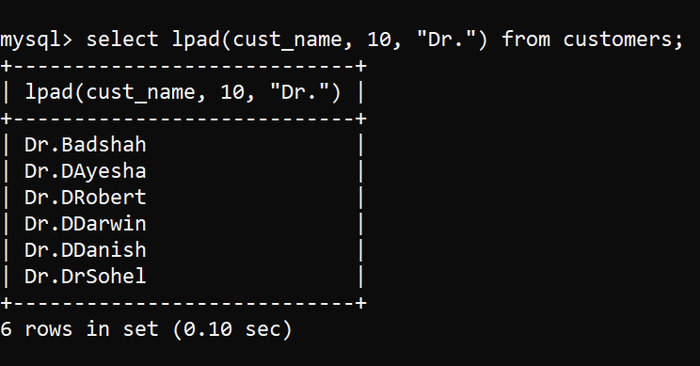

**LTRIM**

Removes leading spaces from a string

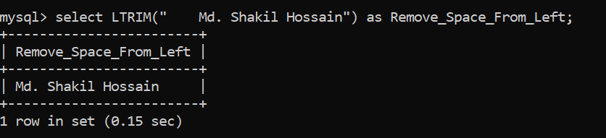

**MID**

Extracts a substring from a string (starting at any position.

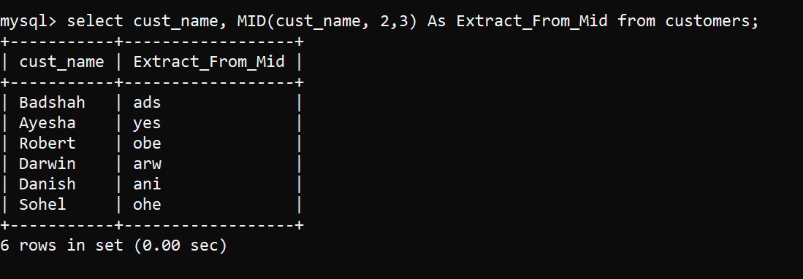

**POSITION**

Returns the position of the first occurrence of a substring in a string

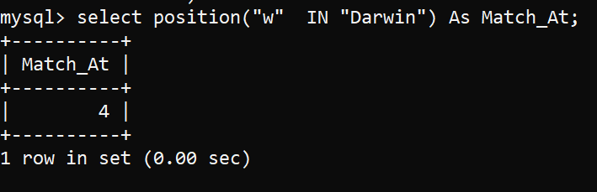

**REPEAT**

Repeats a string as many times as specified

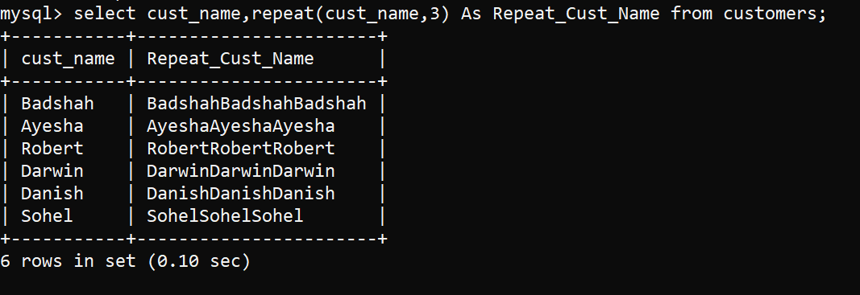

**REPLACE**

Replaces all occurrences of a substring within a string, with a new substring

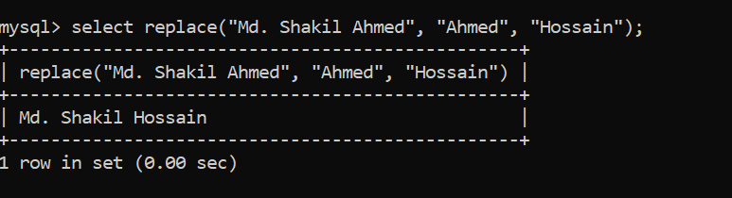

**REVERSE**

Reverses a string and returns the result

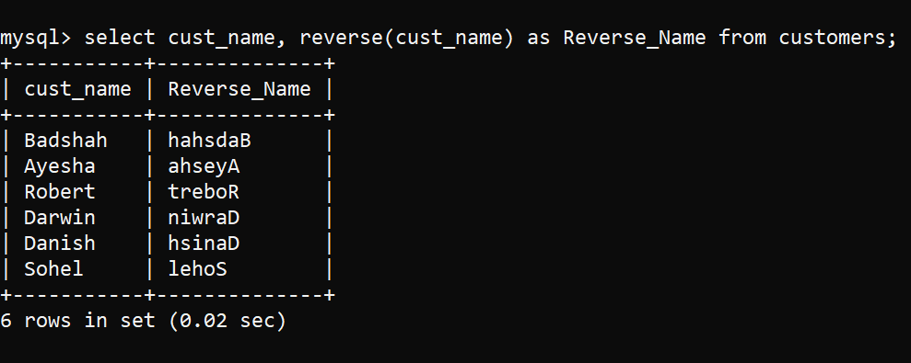

**RIGHT**

The RIGHT( ) function extract right character from string

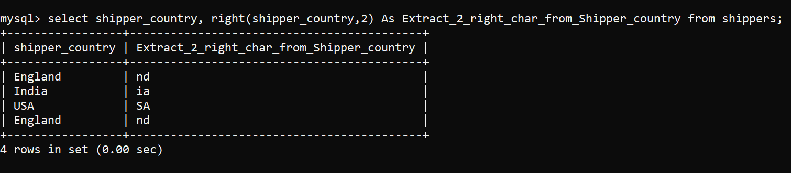

**RPAD**

Right-pads a string with another string, to a certain length

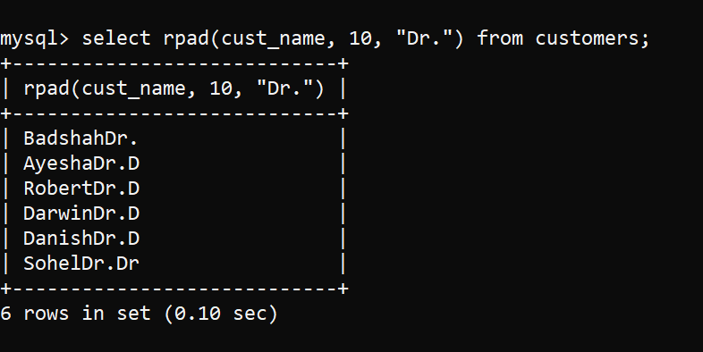

**RTRIM**

Removes trailing spaces from a string

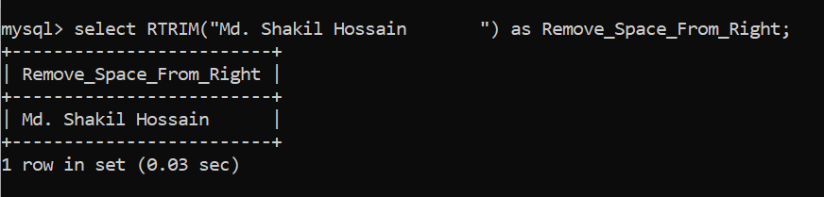

**SPACE**

Returns a string of the specified number of space characters

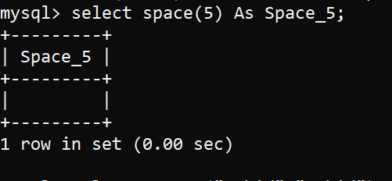

**STRCMP**

Compares two strings

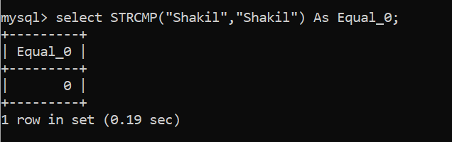

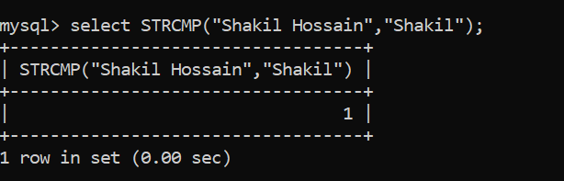

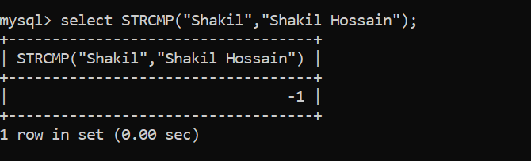

**SUBSTR**

Extracts a substring from a string (starting at any position)

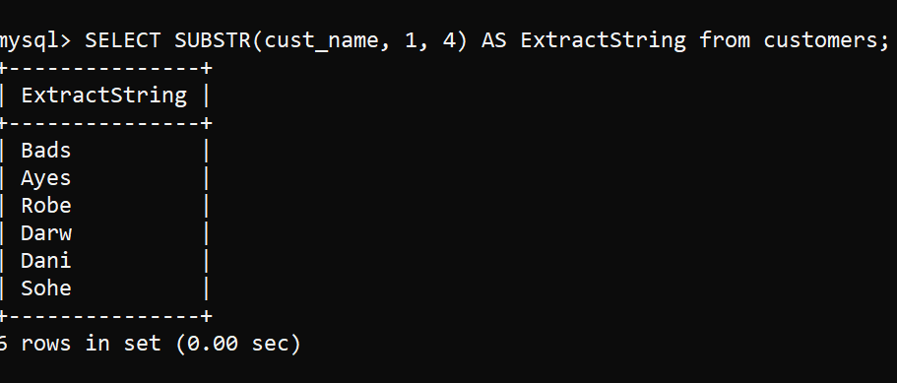

**SUBSTRING**

Extracts a substring from a string (starting at any position)

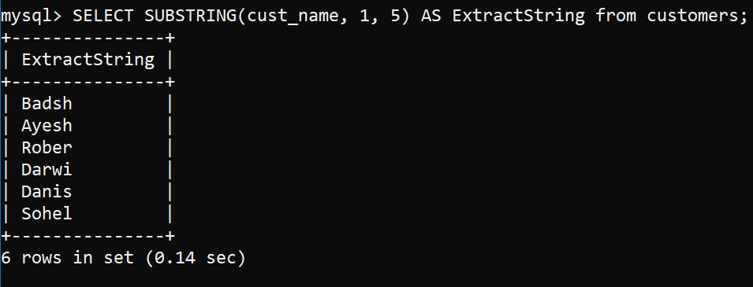

**SUBSTRING_INDEX**

Returns a substring of a string before a specified number of delimiter occurs

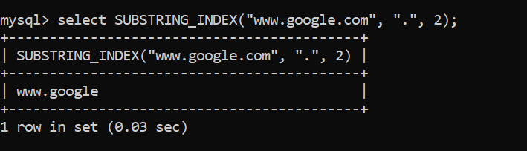

**TRIM**

Removes leading and trailing spaces from a string

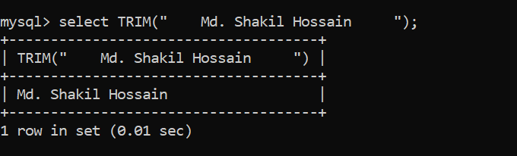

**UCASE**

This function converts a string to upper-case.

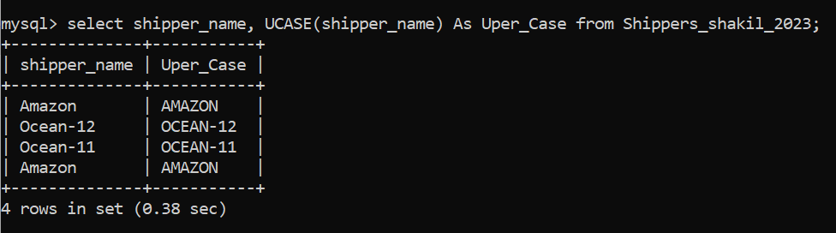

**UPPER**

This function converts a string to upper-case.

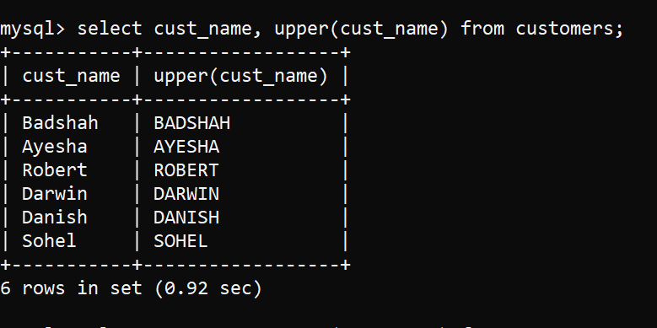

**THE END**